
NAME: BISMA FATIMA
CLASS: CS A
ROLL NO: F24605036
COURSE: INFORMATION SECURITY
COURSE CODE: CS-291
LECTURER: MISS ATTIA ASHRAF

LAB 05

Lab Activities
1. Download WannaCry exe file
- Obtain the provided WannaCry sample from the lab resources.
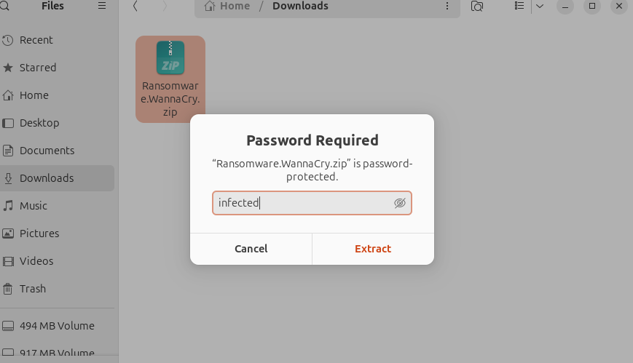
- Store it in your working directory for analysis.
- Add password.
- Extract
- Then add exe file to VirusTool

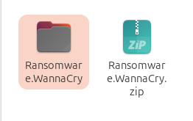
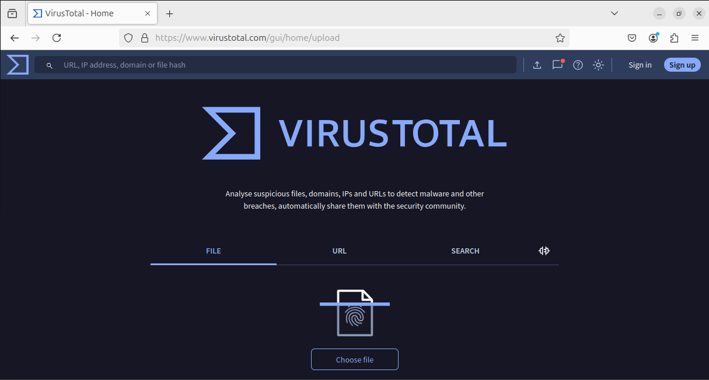

2. Scan on VirusTotal
- Upload the file on VirusTotal.
- Record the detection ratio and note which malware family it is flagged as.

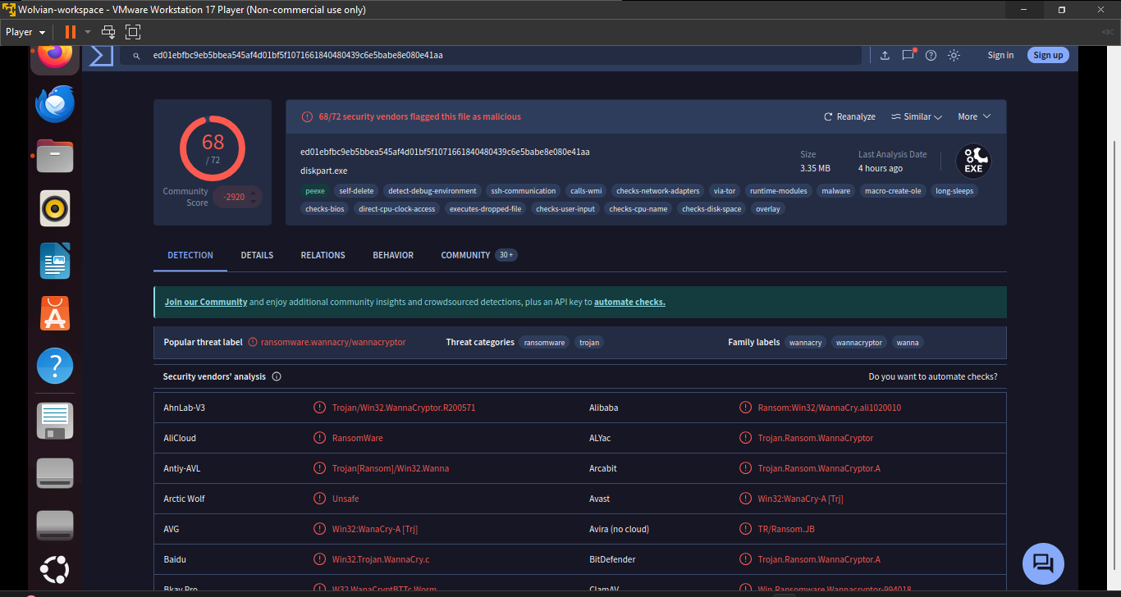
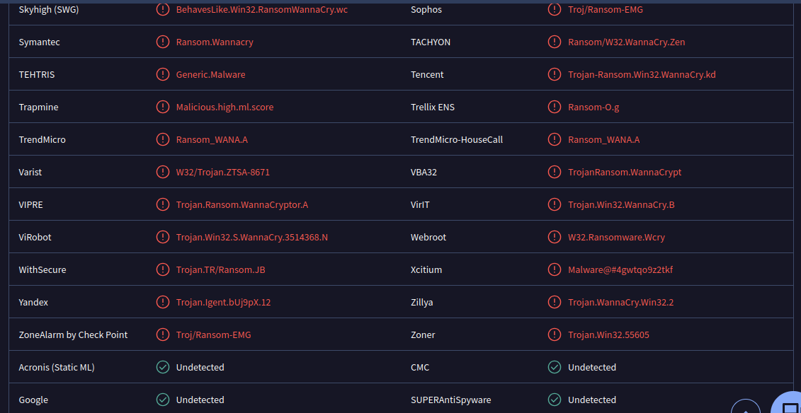
3. Analyze Strings in FLOSS
- Run the floss tool on the executable.
sudo apt update && sudo apt upgrade -y
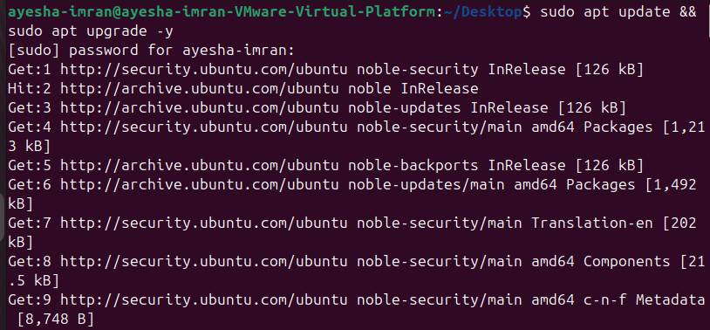
- Install Python & pip (for FLOSS) :
Command: sudo apt install python3 python3-pip -y
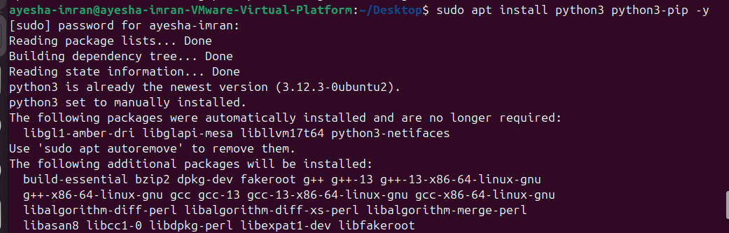
- Install Floss (FireEye’s string analysis tool):
Command: pip install --break-system-packages flare-floss
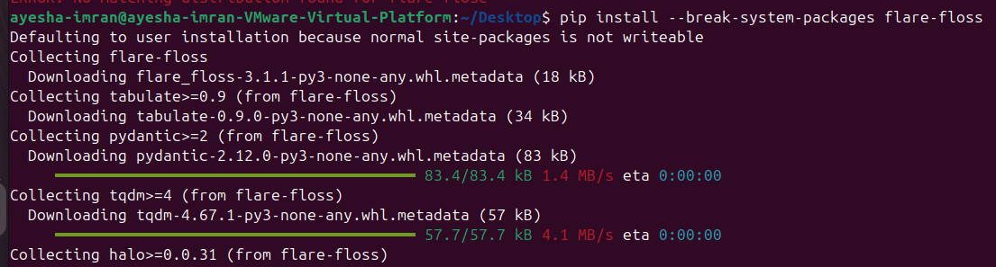

- Extract and review strings.
floss ransomware.exe > ransomware_strings.txt
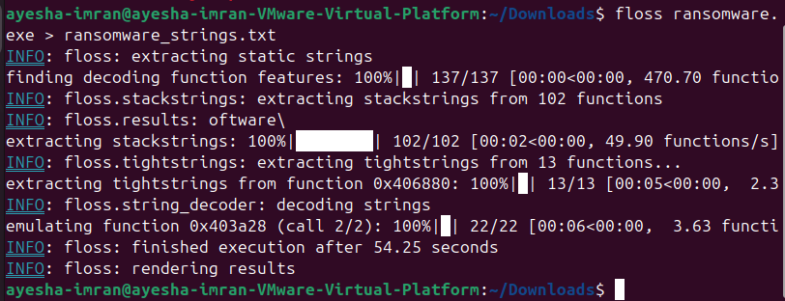
The string file is created:
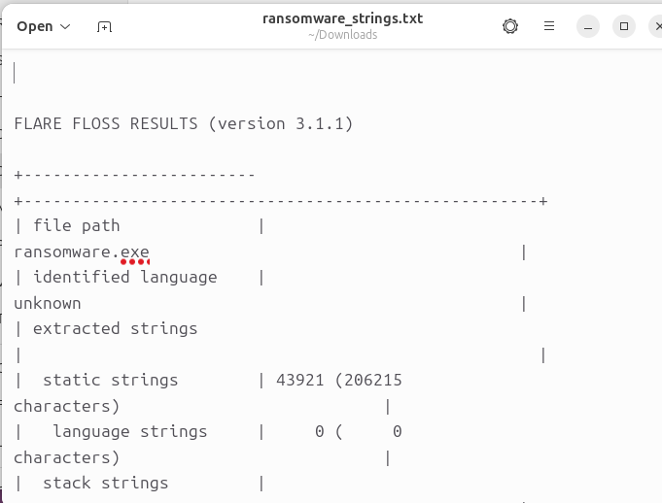

- Identify any suspicious indicators such as URLs, registry paths, or commands.
Suspicious String | Category | What It Reveals
WanaCryptOr | Malware Identity | Confirms the sample is WannaCry ransomware.
.doc, .xls, .ppt, .pdf, .jpg… | Targeted File Extensions | Shows which file types the malware searches for and encrypts.
.pfx, .key, .crt, .csr, .p12… | Cryptographic Focus | Indicates it targets private keys and certificates to disrupt secure systems.
%s\ProgramData | Installation Path | Common directory used for persistence or spreading.
%s\Intel | Alternate Install Path | Another directory used to hide or install malware.
CompanyName: Microsoft Corporation | Fake Metadata | Pretends to be a Microsoft tool to avoid suspicion.
FileDescription: DiskPart | Disguise Technique | Mimics a known Windows utility to trick users.
OriginalFilename: diskpart.exe | Fake Identity | Malware masquerades as a system tool.
ProductVersion: 6.1.7601.17514 | Spoofed Version Info | Fakes Windows version to appear legitimate.
VS_VERSION_INFO | Metadata Structure | Standard version info block in PE files — used to spoof legitimacy.
StringFileInfo, 040904B0 | Locale & Metadata Tags | Common in spoofed metadata to mimic US-based software.

4. Install PEView and Display Internal Structure of Virus
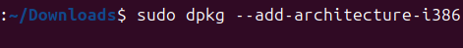
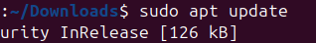
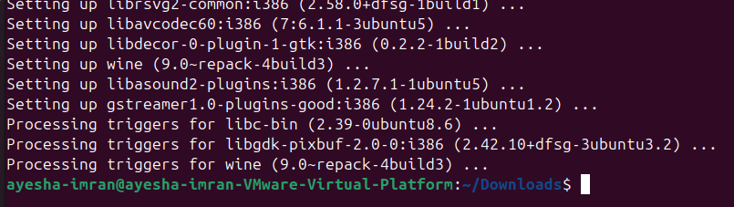
.
5. Install Detect It Easy (DIE) and Detect Packers, Cryptors, and Compilers
- Open the sample in DIE.
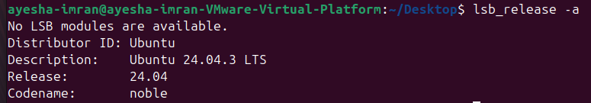
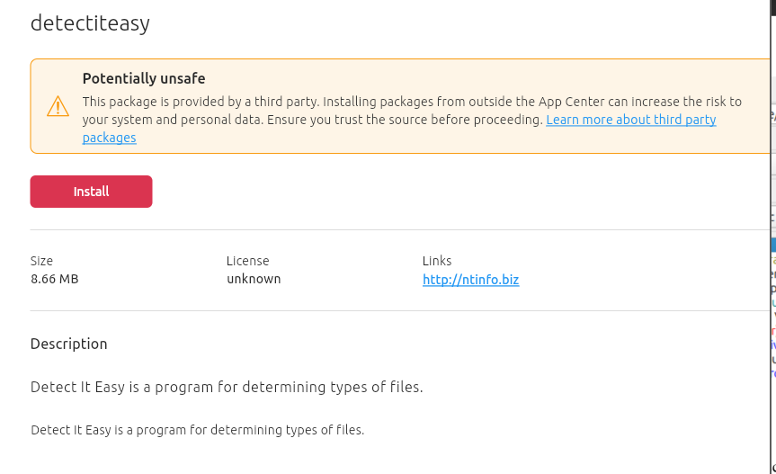

- Run signature detection.
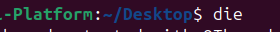
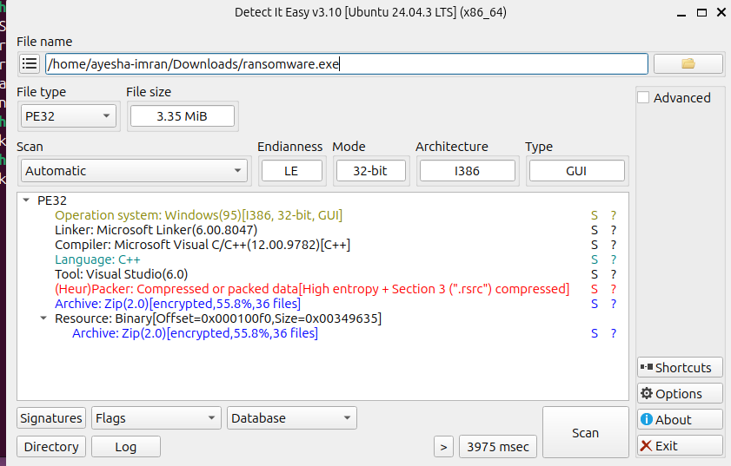
Bisma

- Identify if the file is packed, obfuscated, or compiled with a suspicious tool.
Field / Finding | Details
File Type | PE32 — a 32-bit Windows executable
File Size | 3.35 MiB — matches known WannaCry sample size
Compiler | Microsoft Visual C/C++ 12.00 (Visual Studio 6.0) — used by malware authors
Language | C++ — the ransomware is written in C++
(Heur)Packer Detected | File is packed — uses compression and encryption to hide malicious code
High Entropy in .rsrc | Indicates compressed or encrypted data in the resource section
Archive: Zip(2.0) | Encrypted archive found — 36 hidden files, 55.8% compression ratio
Resource Section Offset/Size | .rsrc section contains encrypted payload — not normal icons or dialogs
Runtime Data Usage | Encrypted files are used during execution — confirms malicious behavior

6. Conclusion
• 🔍 Malicious Classification: The sample is conclusively identified as ransomware based on behavioral and structural indicators.
• FLOSS Findings:
- Detected strings related to encryption routines.
- Revealed targeted file extensions commonly associated with ransomware.
- Exposed deceptive metadata embedded in the binary.
• EView & DIE Analysis:
- Showed the executable is packed, suggesting obfuscation.
- Identified an encrypted resource section, typical of concealed payloads.
- Found a spoofed compilation timestamp, indicating an attempt to mislead forensic analysis.
• Intent & Functionality:
- The file is engineered to encrypt user data.
- Designed to evade detection through multiple layers of obfuscation.

